(cal.B612)
- Important instructions that should be followed are classified with the following symbols.
Safety precautions
(Instructions to be followed at all times)
This manual contains the following
instructions that should be strictly followed at all times to prevent injury to yourself and other persons as well as damage to property.
- Injuries and damage that might be caused by using the watch improperly or neglecting any of the instructions or precautions contained in this manual are classified with the following symbols.
Instruction Manual
Thank you for your purchase of this Citizen watch.
Before using the watch, read this instruction manual carefully to ensure correct use.
After reading the manual, store it in a safe place for future reference.
Warning (caution) symbol followed by prohibited matters.
Warning (caution) symbol followed by instructions that should be followed or precautions that should be observed.
Can or will cause
CAUTION minor or moderate
injury or damage.
injury or death.
WARNING Can cause serious
Highly likely to
DANGER cause death or
serious injury.
To check the movement number
A case number is engraved on the case back. (See the figure below.)
On the case back, a number composed of four + six alphanumeric characters (or more) is engraved.
In the example below, “1234” is the movement number.
<Engraving position example>

1234-567890

The engraving position may differ depending on watch model.
PAE07
Notes Before Use
Component identification
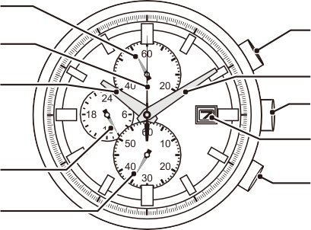
Chronograph minute hand
Precautionary Items and Usage Limitations
CAUTION To avoid injury
Warranty and Service

Chronograph second hand
<Notes before use — Protective stickers>
Prior to the watch being shipped from the manufacturing plant, its glass, case, metal band, and metal parts of clasp are covered with stickers to protect them from getting fingerprint or scratches during transit from the plant to the store.
If the watch is worn without first removing these stickers, perspiration or moisture may enter the gaps between the protective stickers and the parts, which may result in a skin rash a skin rash and/or corrosion of the metal parts. For this reason, please be sure to peel off stickers before wearing the watch.

Hour hand

24-hour hand Second hand
Button (B)

Minute hand Crown
Date indicator

Button (A)
* The illustrations shown in this manual may differ from the actual watch you have purchased.

- Be particularly careful when wearing your watch while holding a small child, to avoid injury.
- Be particularly careful when engaged in strenuous exercise or work, to avoid injury to yourself and others.
- Do NOT wear your watch while in a sauna or other location
WARNING Water Resistance

- Non-water resistant watches cannot be used underwater or in environments in contact with water.
- Water-resistance for daily use (to 3 atmospheres) means that the watch may be worn while washing your face or in the rain, but is not to be immersed in water.
- Upgraded water-resistance for daily use (to 5 atmospheres) means that the watch may be worn while swimming, but is not to worn while skin diving.
Setting the Time

where your watch may become excessively hot, since there is the risk of burns.
- Be careful when putting on and taking off your watch, since there is a risk of damaging your fingernails, depending on the manner in which the band is fastened.

- Upgraded water-resistance for daily use (to 10/20 atmospheres) means that the watch may be worn while skin diving, but not while scuba or saturated diving using helium gas.
- Refer to the watch dial and the case back for the indication of the water resistance of your watch. The following chart provides examples of use for reference to ensure that your watch is used properly. (The unit “1bar” is roughly equal to 1 atmosphere.)
- WATER RESIST(ANT) ××bar may also be indicated as
  - 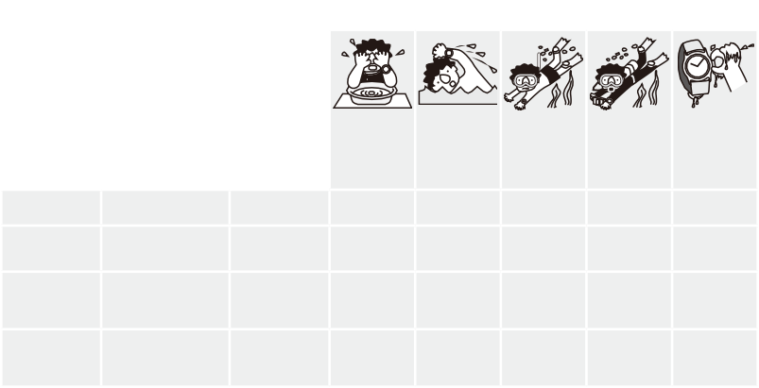.××bar.

<Free Guarantee>

In the case a malfunction has occurred during the course of normal use while the watch is till under warranty, the watch will be repaired free of charge in accordance with the conditions of the warranty included with this manual.
<Stock Period of Repair Parts> Our standard period for stocking repair parts for each model is generally seven year. When an exterior part such as the watch case, glass, dial, hand, crown or band is damaged, a spare part with different appearance may sometimes be

This watch has a rechargeable cell which is charged by exposing the dial to light, such as direct sunlight or fluorescent lamps. After taking off the watch, put it in a location where the dial is exposed to bright
Notes on charging your watch
Water-related use

Name
Indication
Watch face or Specifications
case back
used.
<Repair Period>
Repairs can be performed on your watch
within the repair parts stock period even after the free guarantee has expired.

light, such as by a window.
NO | NO | NO | NO | NO
OK | NO | NO | NO | NO
OK | OK | NO | NO | NO
OK | OK | OK | NO | NO

Minor
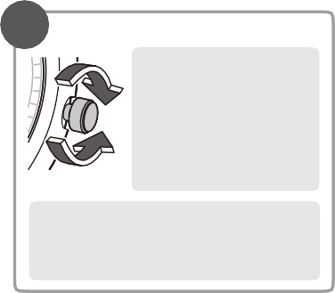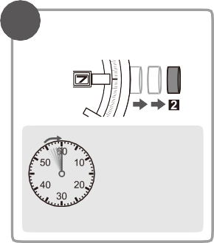exposure to
2 Rotate the crown to set the time.
Move the minute hand ahead of the correct time by 5 “minutes” and then return the hand to the correct “minutes”. This will minimize the effect of gear play and will provide more accurate hand movement.

The 24-hour hand (located at the 9:00 subdial) moves in relation to the hour hand. Determine whether it is a.m. or p.m. by observing the 24-hour hand.
1 Pull the crown out to position 2.
Pull out the crown just as the second hand is at the reference position in order
to accurately align to the second.
Moderate
exposure to
Skin diving,
marine
Scuba diving
using
Pulling out the
crown when

However, you will be charged for these

water (washing water (washing,
sports
an air tank
the

For optimal performance, perform the following:
    - 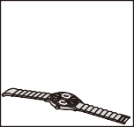Expose the watch with the dial facing towards direct sunlight for five to six hours

Non-water- resistant watch
Everyday-use

Non-water- resistant
Water-resistant to
—
face, rain, etc.)
kitchen work, swimming, etc.)
watch is wet

repairs. Please take the watch to the shop where you purchased it and ask whether it can be repaired because the repair period varies according to the conditions of use,

at least once a month.
water-resistant
watch
WATER RESIST (ANT)
3 atmospheres

environment and so forth. Moreover,

- Before storing the watch in
3 Press the crown back into its normal position.
Be sure to secure if the watch has a screw down crown.
Water may enter your watch.
Setting the Date
Upgraded everyday-use
WATER RESIST (ANT) Water-resistant to

there are cases in which it is difficult to

a dark place for an extended
water-resistant watch
Upgraded
5 bar
5 atmospheres

restore the watch to its original accuracy
when decreased accuracy has resulted

period of time, be sure to charge it fully.
everyday-use
WATER RESIST (ANT) Water-resistant to

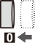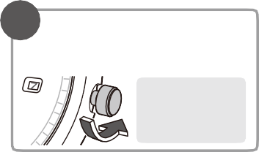water-resistant watch
3 Press the crown back into its normal position.

Be sure to secure if the watch has a screw down
crown. Water may enter your watch.
2 Rotate the crown counterclockwise to set the date. The date will not change when
the crown is rotated clockwise.
The date does not change when you rotate the crown to the right.
1 Pull the crown out to position 1.
- When the watch is regularly covered with long sleeves, it may not be charged sufficiently. Try to keep the watch exposed to light sufficient for charging.
- Do not charge the watch at a high temperature (about 60ºC
or higher).
10/20 bar
10 or 20 atmospheres

from long-term use.
<Change of Address or Receiving as a Gift>
CAUTION Precautions
CAUTION Always keep your Watch Clean
In the event that you have moved or have

About the crown
Some models use screw down system for the crown. Accidental operations can be prevented when the watch is not being operated by locking the crown. To operate the watch, release the lock.
- If your watch does not have a screw down crown, operations can be performed without locking or unlocking the crown.
Before operation
After operation

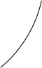
Unlock the crown
Rotate the crown to the left (counterclockwise).

When the screw lock is released, the crown extends to the normal position.
Lock the crown
Press the crown and rotate it to the right (clockwise) to tighten the screw lock.
Your Watch

Eco-Drive (solar powered) watch
The watch operates by converting sunlight and other light into electrical energy. Once the rechargeable cell is fully charged, the watch will function for approximately 7 months.
Time: Hour, minute, second, and 24-hour
Calendar: Date (does not automatically adjust for months shorter than 31-days)
Chronograph (measures up to 60 minutes in 0.2-second units), Insufficient Charge
Warning Function, Overcharge Prevention Function, Quick Start Function
Time until stop from full charged status without additional charging: Approx. 7 months
Time until stop from activation of insufficient charge warning function:
Approx. 7 days
Rechargeable cell (lithium button cell),1pc
Operation time:

Battery:
Additional functions:
Time accuracy: Within +/-15 seconds per
month when worn at normal operating temperatures (+5°C to +35°C)
Operational
temperature −10°C to +60°C range:
Display functions:
B612
Analogue solar powered watch
Cal. No.:
Type:
Specifications
Insufficient charge warning
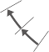If the power becomes very low, the second hand advances at 2-second intervals, indicating that charging is necessary. When the second hand starts to advance at 2-second intervals, expose the watch to light until it is fully charged.
If the watch is not exposed to light within approximately 7 days after the insufficient charge warning starts, the watch will stop.

Quick start function
When the stopped watch is exposed to light, it starts operating again immediately.
After quick start, expose the watch to light until it is fully charged. Set the correct time before using the watch.

Replacement of Rechargeable Cell
Because the watch uses a rechargeable cell, you do not need periodical cell replacement.
However, power consumption may increase after using for an extended period of time due to deterioration, and the power may run out earlier than expected. To avoid this, we recommend that you have your watch inspected (Charge basis) periodically.

The date must be manually adjusted for months shorter than 31-days. You will need to adjust the date at the start of March, May, July, October and December.
Do not adjust the date between 9 p.m. and 1 a.m. If you change the date during this time, the date may not change the following day.
Using the Chronograph
The chronograph can measure up to 60 minutes in 0.2-second units.

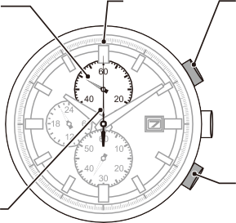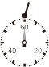
Chronograph minute hand
Reference position of the chronograph minute hand
Reference position
Chronograph second hand
Time measurement start/stop [button(B)]
① To start the chronograph, press and release the upper right button (B) to commence time measurement.
② To stop the chronograph, press and release the upper right button (B) again.
③ To recommence timing from the stopped position, press and release the upper right button (B) again.
Pressing and releasing the lower right button (A) during chronograph operation will cause timing to stop and the chronograph to reset.
Reset [button(A)]
To reset the chronograph after stopping time measurement, press and release the lower right button (A).

Caution The chronograph minute/second hands may be come misaligned if the watch is subjected to a strong knock.
If the position cannot be corrected by using the reset procedures outlined on pages 12-13, please contact your nearest Authorized Service Center.
When the chronograph second hand does not return to the reference position
If the chronograph second hand does not return to reference position even when reset, perform the following procedures to align the chronograph second hand with the reference position.
The chronograph does not function if the crown is pulled out to position 2.
The chronograph resets if the crown is pulled out to position 2 during measurement.
Time is stopped while aligning with the reference position. Set the time after aligning.

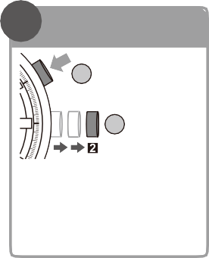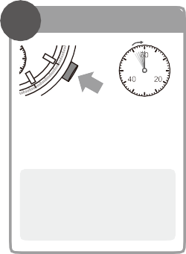
1
Set the watch to correct the reference position
① Pull the
2 crown out to position 2.
1
② Press and hold the upper right button (B) for 3 seconds or more.
The watch is now set to correct the reference position.
2
Correct the position of the second hand
① Press and release
1
2
the upper right button (B) to adjust the position of
the chronograph second hand.
- Press once Second hand moves ahead at one-second intervals.
- Press and hold down Second hand advances rapidly.
If the second hand does not move even when the upper right button (B) is pressed, perform Step 1 of the page on the left.
② Press the crown back into its normal position.
3
Reset the minute hand
Press and release the lower right button (A) to adjust the position of the
chronograph minute hand.
The chronograph minute
hand moves together with
the second hand when
correcting the second hand.
Reset the minute hand.

Be sure to secure if the watch has a screw down crown and/or screw down push button. Water may enter your watch.

Guide to Charging Time
Below are the approximate times needed for charging when exposing the watch dial to light continuously. Please use this table as a reference only.

Environment | Illuminance (Lx) | Charging time to work for one day | Charging time to start working normally when the rechargeable cell is empty | Charging time to the fully charged state when the rechargeable cell is empty
Under direct sunlight or cloudy weather (not through a window) | 10,000  to 100,000 | 2 to 11 minutes | 25 minutes  to 3.5 hours | 8.5 hours to 45 hours
20 cm under a fluorescent lamp (30 W) | 3,000 | 35 minutes | 11 hours | 150 hours
Interior lighting | 500 | 3.5 hours | 80 hours | ＊

This watch wil run for approximately 7 months from a full charge without further exposure to light.
＊ To charge the rechargeable cell fully, it is recommended to expose the dial to direct sunlight.
A fluorescent lamp or interior lighting does not have sufficient illumination to charge the rechargeable cell fully.
- Always use the watch with the crown pushed in (normal position). If the crown is of the screw lock-type, make sure it is securely locked.
- Do NOT operate the crown when the watch is wet. Water may penetrate into the watch, causing deterioration of water resistance.
- If water enters the watch or the watch fogs up and does not clear up even after a long time, consult your dealer or Customer Support Center for inspection and/or repair.
- If a watch of upgraded water resistance for daily use is immersed in sea water or subjected to excessive perspiration, thoroughly rinse with fresh water and wipe completely dry with a soft cloth.
- If seawater enters the watch, place the watch in a box or plastic bag and immediately take it in for repair. Otherwise, pressure inside the watch will increase, and parts (crystal, crown, buttons, etc.) may come off.
CAUTION When Wearing your Watch

<Band>
- The durability of a leather band may be affected when wet (fading, peeling of adhesive), owing to the properties of the material. Moreover, wet leather may cause a rash.
- It is recommended to take off the watch if it gets wet, even if the watch itself is water-resistant.
- Do Not wear the band too tightly. Try to leave enough space between the band and your skin to allow adequate ventilation.
- The rubber (urethane) band may be stained by dyes or soil present in or on clothing or other accessories.
Since these stains may not be removable, caution is required when wearing your watch with items that tend to easily transfer color (articles of clothing, purses, etc.). In addition, the band may be deteriorated by solvents or moisture in the air. Replace with a new one when it has lost elasticity or become cracked.

<Temperature>
- The watch may stop or the function of the watch may be impaired in extremely high or low temperature.
Do not use the watch in places where the temperature is outside the operating temperature range as stated in the specifications.

<Static Electricity>
- The integrated circuits (IC) used in quartz watches are sensitive to static electricity. Please note that the watch may not indicate the correct time if exposed to intense static electricity.

<Magnetism>
- Analog quartz watches are powered by a step motor that uses a magnet. Subjecting the watch to strong magnetism from the outside can cause the motor to operate improperly and prevent the watch from indicating the correct time. Do not allow the watch to come into close proximity to magnetic health devices (magnetic necklaces, magnetic elastic bands, etc.) or the magnets used in the latches of refrigerator doors, clasps used in handbags, the speaker of a cell phone, electromagnetic cooking devices and so on.

<Strong Shock>
- Avoid dropping the watch or subjecting it to other strong impact. It may cause malfunctions and/or performance deterioration as well as damage to the case and bracelet.

<Chemicals, Corrosive Gasses and Mercury>
- If paint thinner, benzene or other solvents or products containing these solvents (including gasoline, nailpolish remover, cresol, bathroom cleaners and adhesives, water repellent, etc.) are allowed to come into contact with the watch, the may discolor, dissolve or crack the materials. Be careful when handling these chemicals. Contact with mercury such as that used in thermometers may also cause discoloration of the band and case.
- Rotate the crown while it is pressed in fully and press the buttons periodically so they do not become stuck due to accumulations of foreign matter.
- The case and band of the watch come into direct contact with the skin in the same manner as undergarments. Corrosion of the metal or unnoticed soiling such as that caused by perspiration and dirt can soil sleeves and other portions of clothing. Keep your watch clean at all times.
- The case and band of the watch come into direct contact with the skin. Rust, dirt or perspiration present on the watch's body or band may cause itching or a rash on your skin. Such problems may also occur if you have an allergy to certain metals or leather. If you think there is something wrong, discontinue wearing the watch immediately and consult your physician.
- Leather bands may become discolored by perspiration or dirt. Always keep your leather band clean by wiping with a dry cloth.
CAUTION Caring for your Watch
- Wipe any dirt or moisture such as perspiration from the case and crystal with a soft cloth.
- For a metallic, plastic or rubber watchband, wash any dirt off with water. Remove the small amounts of dirt trapped between the crevices of the metallic band with a soft brush.
- If you will not be using your watch for an extended period of time, carefully wipe off any perspiration, dirt or moisture and store in a proper location, avoiding locations subject to excessively high or low temperatures and high humidity.

<About the Watch with Luminous Paint>
The paint on the dial and hands helps you with reading the time in a dark place. The luminous paint stores daylight or artificial light (not including incandescent lighting) and glows in a dark place.
It is free from any radioactive substance or any other material harmful to a human body or environment.
- The light emission gradually becomes weaker as time passes.
- The duration of the light (“glow”) will vary depending on the brightness, types of and distance from a light source, exposure time, and the amount of the paint.
- The paint may not glow and/or may dissipate quickly if exposure to light was not sufficient.
WARNING Handling of Rechargeable Cell
- The rechargeable cell should never be removed from the watch. If for any reason it becomes necessary to remove the rechargeable cell from the watch, keep out of the reach of children to prevent accidental swallowing.
If the rechargeable cell is accidentally swallowed, consult a doctor immediately.
- Do not dispose of the rechargeable cell with ordinary garbage. Please follow the instructions of your municipality regarding collection of batteries to prevent the risk of fire or environmental contamination.
WARNING Use Only the Specified Battery
- Never use a battery other than the rechargeable cell specified for use in this watch.
Although the watch structure is designed so that it will not operate when another type of battery is installed, if a silver battery or other type of battery is installed in the watch and the watch is recharged, there is the risk of overcharging which may cause the battery to rupture.
This can cause damage to the watch and injury to the wearer. When replacing the rechargeable cell, always make sure to use the designated rechargeable cell.
CAUTION Recharging Precautions
- Do not charge the watch at a high temperature (about 60°C or higher) as doing so may cause the movement to malfunction.

Examples:
- Charging the watch too close to a light source which generates a large amount of heat such as an incandescent lamp or halogen lamp.
* When charging under an incandescent lamp, be sure to leave 50cm or more between the lamp and the watch to avoid exposing the watch to excessive heat.
- Charging the watch in a location where the temperature may become extremely high such as on the dashboard of a vehicle.

received your watch as a gift, and are not able to bring your watch to the shop where it was purchased for serving, please consult Customer Support Center.
<Periodic Inspection (Charge Basis)>
You should have your watch inspected every 2-3 years to extend its life and ensure safety. (charge basis)
When replacing parts, always make sure to request genuine parts. When it becomes necessary to replace packings and springs, it may sometimes also be necessary to inspect other parts or to make repairs in addition to replacing the parts. Please ask for more detailed information on repair or replacement expenses at the shop where you purchased your watch or Customer Support Center.
<Other Inquiries>
If you have any questions regarding the way warranty, repairs or other matters, please inquire at the shop where you purchased your watch or Customer Support Center.

Memo

